**Roll No: 23AI61**

**Batch: 3**

**EXPERIMENT NO: 03**

**AIM:** Design the web page for online book store using bootstrapping.

**REQUIREMENTS:** Web Browser,Notepad

**THEORY:**

Bootstrap is a powerful, feature-packed frontend toolkit. Build anything—from prototype to production—in minutes.

A typical mobile-optimized site contains something like the following:

<meta name="viewport" content="width=device-width, initial-scale=1">

Not all devices are the same width; you should make sure that your pages work well in a large variation of screen sizes and orientations.The basic properties of the "viewport" <meta> tag include:

Width : Controls the size of the viewport. It can be set to a specific number of pixels

like width=600 or to the special value device-width, which is [100vw](https://developer.mozilla.org/en-US/docs/Web/CSS/length#relative_length_units_based_on_viewport), or 100% of the viewport width. Minimum: 1. Maximum: 10000. Negative values: ignored.

Height: Controls the size of the viewport. It can be set to a specific number of pixels

like height=400 or to the special value device-height, which is [100vh](https://developer.mozilla.org/en-US/docs/Web/CSS/length#vh), or 100% of the viewport height. Minimum: 1. Maximum: 10000. Negative values: ignored.

initial-scale: Controls the zoom level when the page is first loaded. Minimum: 0.1. Maximum: 10. Default:1. Negative values: ignored.

minimum-scale: Controls how much zoom out is allowed on the page. Minimum: 0.1. Maximum: 10. Default: 0.1. Negative values: ignored.

maximum-scale: Controls how much zoom in is allowed on the page. Any value less than 3 fails accessibility. Minimum: 0.1. Maximum: 10. Default:10. Negative values: ignored.

user-scalable: Controls whether zoom in and zoom out actions are allowed on the page. Valid values: 0, 1, yes, or no. Default: 1, which is the same as yes. Setting the value to 0, which is the same as no, is against Web Content Accessibility Guidelines (WCAG).

1. Grid system: Bootstrap’s grid system uses a series of containers, rows, and columns to layout and align content. It’s built with [flexbox](https://developer.mozilla.org/en-US/docs/Web/CSS/CSS_Flexible_Box_Layout/Using_CSS_flexible_boxes) and is fully responsive. Below is an example and an in-depth look at how the grid comes together.

<divclass="container">

<divclass="row">

<divclass="col-sm">

One of three columns

</div>

<divclass="col-sm">

One of three columns

</div>

<divclass="col-sm">

One of three columns

</div>

</div></div>

Form:

<form>

<divclass="form-group">

<labelfor="exampleFormControlInput1">Email address</label>

<inputtype="email"class="form- control"id="exampleFormControlInput1"placeholder[="name@example.com">](mailto:name@example.com)

</div>

<divclass="form-group">

<labelfor="exampleFormControlSelect1">Example select</label>

<selectclass="form-control"id="exampleFormControlSelect1">

<option>1</option>

<option>2</option>

<option>3</option>

<option>4</option>

<option>5</option>

</select>

</div>

<divclass="form-group">

<labelfor="exampleFormControlSelect2">Example multiple select</label>

<selectmultipleclass="form-control"id="exampleFormControlSelect2">

<option>1</option>

<option>2</option>

<option>3</option>

<option>4</option>

<option>5</option>

</select>

</div>

<divclass="form-group">

<labelfor="exampleFormControlTextarea1">Example textarea</label>

<textareaclass="form-control"id="exampleFormControlTextarea1"rows="3"></textarea>

</div></form>

Form controls : Textual form controls—like <input>s, <select>s, and <textarea>s—are styled with the .form-control class. Included are styles for general appearance, focus state, sizing, and more.

Buttons: Bootstrap includes several predefined button styles, each serving its own semantic purpose, with a few extras thrown in for more control.

<buttontype="button"class="btn btn-primary">Primary</button>

<buttontype="button"class="btn btn-secondary">Secondary</button>

<buttontype="button"class="btn btn-success">Success</button>

<buttontype="button"class="btn btn-danger">Danger</button>

<buttontype="button"class="btn btn-warning">Warning</button>

<buttontype="button"class="btn btn-info">Info</button>

<buttontype="button"class="btn btn-light">Light</button>

<buttontype="button"class="btn btn-dark">Dark</button>

<buttontype="button"class="btn btn-link">Link</button>

Description: Untitled

Navbars :

* Navbars require a wrapping .navbar with .navbar-expand{-sm|-md|-lg|-xl} for responsive collapsing and [color scheme](https://getbootstrap.com/docs/4.0/components/navbar/#color-schemes) classes.
* Navbars and their contents are fluid by default. Use [optional containers](https://getbootstrap.com/docs/4.0/components/navbar/#containers) to limit their horizontal width.
* Use our [spacing](https://getbootstrap.com/docs/4.0/utilities/spacing/) and [flex](https://getbootstrap.com/docs/4.0/utilities/flex/) utility classes for controlling spacing and alignment within navbars.
* Navbars are responsive by default, but you can easily modify them to change that. Responsive behavior depends on our Collapse JavaScript plugin.
* Navbars are hidden by default when printing. Force them to be printed by adding .d- print to the .navbar. See the [display](https://getbootstrap.com/docs/4.0/utilities/display/) utility class.
* Ensure accessibility by using a <nav> element or, if using a more generic element such as a <div>, add a role="navigation" to every navbar to explicitly identify it as a landmark region for users of assistive technologies.

1. Breadcrumb: Indicate the current page’s location within a navigational hierarchy that automatically adds separators via CSS.

<navaria-label="breadcrumb">

<olclass="breadcrumb">

<liclass="breadcrumb-item active"aria-current="page">Home</li>

</ol></nav>

<navaria-label="breadcrumb">

<olclass="breadcrumb">

<liclass="breadcrumb-item"><ahref="#">Home</a></li>

<liclass="breadcrumb-item active"aria-current="page">Library</li>

</ol></nav>

<navaria-label="breadcrumb">

<olclass="breadcrumb">

<liclass="breadcrumb-item"><ahref="#">Home</a></li>

<liclass="breadcrumb-item"><ahref="#">Library</a></li>

<liclass="breadcrumb-item active"aria-current="page">Data</li>

</ol></nav>

1. Jumbotron : A lightweight, flexible component that can optionally extend the entire viewport to showcase key marketing messages on your site.

<divclass="jumbotron">

<h1class="display-4">Hello, world!</h1>

<pclass="lead">This is a simple hero unit, a simple jumbotron-style component for calling extra attention to featured content or information.</p>

<hrclass="my-4">

<p>It uses utility classes for typography and spacing to space content out within the larger container.</p>

<pclass="lead">

<aclass="btn btn-primary btn-lg"href="#"role="button">Learn more</a>

</p></div>

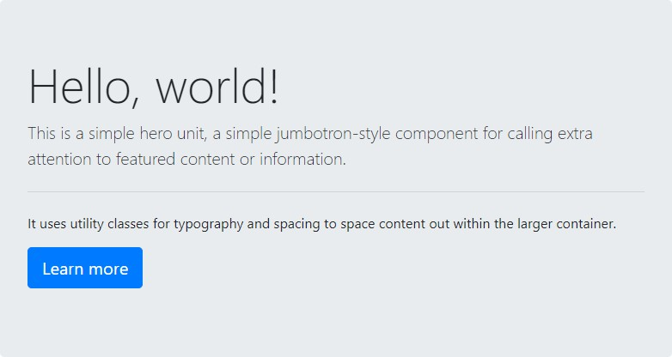

**CODE:**

Github link: <https://github.com/muiztakey2005/Experiment-3-WC-.git>

**SNAPSHOT OF OUTPUT:**

**Paste or attach the screenshot of your output.**

**CONCLUSION:**

We have studied bootstraping and used it to implement the website pages.